**INDIA GENERAL ELECTIONS RESULT ANALYSIS 2024**

**PROBLEM STATEMENTS**

**1)Total Seats**

select

DISTINCT COUNT(parliament_constituency) as Total_seats

from constituencywise_results

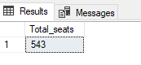

**2) What is the total number of seats available for elections in each state**

SELECT

s.state as State_name,

COUNT(cr.parliament_constituency) as Total_Seats

FROM

constituencywise_results cr

INNER JOIN statewise_results sr on cr.Parliament_Constituency=sr.Parliament_Constituency

INNER JOIN states s on sr.State_ID =s.state_id

group by s.state

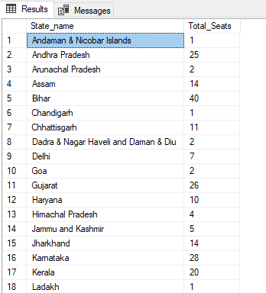

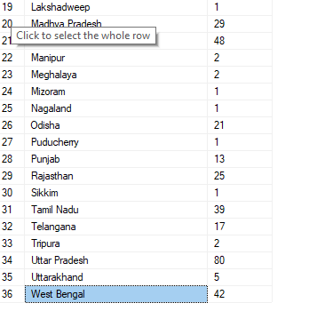

**3) Total Seats Won by NDA Allianz**

SELECT

SUM(CASE

WHEN party IN (

'Bharatiya Janata Party - BJP',

'Telugu Desam - TDP',

'Janata Dal (United) - JD(U)',

'Shiv Sena - SHS',

'AJSU Party - AJSUP',

'Apna Dal (Soneylal) - ADAL',

'Asom Gana Parishad - AGP',

'Hindustani Awam Morcha (Secular) - HAMS',

'Janasena Party - JnP',

'Janata Dal (Secular) - JD(S)',

'Lok Janshakti Party(Ram Vilas) - LJPRV',

'Nationalist Congress Party - NCP',

'Rashtriya Lok Dal - RLD',

'Sikkim Krantikari Morcha - SKM'

) THEN [Won]

ELSE 0

END) AS NDA_Total_Seats_Won

FROM partywise_results

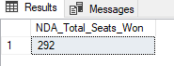

**4) Seats Won by NDA Allianz Parties**

SELECT

party as Party_Name,

won as Seats_Won

FROM

partywise_results

WHERE

party IN (

'Bharatiya Janata Party - BJP',

'Telugu Desam - TDP',

'Janata Dal (United) - JD(U)',

'Shiv Sena - SHS',

'AJSU Party - AJSUP',

'Apna Dal (Soneylal) - ADAL',

'Asom Gana Parishad - AGP',

'Hindustani Awam Morcha (Secular) - HAMS',

'Janasena Party - JnP',

'Janata Dal (Secular) - JD(S)',

'Lok Janshakti Party(Ram Vilas) - LJPRV',

'Nationalist Congress Party - NCP',

'Rashtriya Lok Dal - RLD',

'Sikkim Krantikari Morcha - SKM'

)

ORDER BY Seats_Won DESC

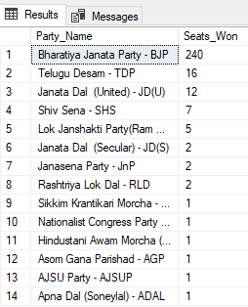

**5) Total Seats Won by I.N.D.I.A. Allianz**

SELECT

SUM(CASE

WHEN party IN (

'Indian National Congress - INC',

'Aam Aadmi Party - AAAP',

'All India Trinamool Congress - AITC',

'Bharat Adivasi Party - BHRTADVSIP',

'Communist Party of India (Marxist) - CPI(M)',

'Communist Party of India (Marxist-Leninist) (Liberation) - CPI(ML)(L)',

'Communist Party of India - CPI',

'Dravida Munnetra Kazhagam - DMK',

'Indian Union Muslim League - IUML',

'Nat`Jammu & Kashmir National Conference - JKN',

'Jharkhand Mukti Morcha - JMM',

'Jammu & Kashmir National Conference - JKN',

'Kerala Congress - KEC',

'Marumalarchi Dravida Munnetra Kazhagam - MDMK',

'Nationalist Congress Party Sharadchandra Pawar - NCPSP',

'Rashtriya Janata Dal - RJD',

'Rashtriya Loktantrik Party - RLTP',

'Revolutionary Socialist Party - RSP',

'Samajwadi Party - SP',

'Shiv Sena (Uddhav Balasaheb Thackrey) - SHSUBT',

'Viduthalai Chiruthaigal Katchi - VCK'

) THEN [Won]

ELSE 0

END) AS INDIA_Total_Seats_Won

FROM

partywise_results

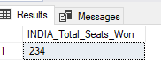

**6)Seats Won by I.N.D.I.A. Allianz Parties**

SELECT

    party as Party_Name,

    won as Seats_Won

FROM

    partywise_results

WHERE

    party IN (

        'Indian National Congress - INC',

                'Aam Aadmi Party - AAAP',

                'All India Trinamool Congress - AITC',

                'Bharat Adivasi Party - BHRTADVSIP',

                'Communist Party of India  (Marxist) - CPI(M)',

                'Communist Party of India  (Marxist-Leninist)  (Liberation) - CPI(ML)(L)',

                'Communist Party of India - CPI',

                'Dravida Munnetra Kazhagam - DMK',

                'Indian Union Muslim League - IUML',

                'Nat`Jammu & Kashmir National Conference - JKN',

                'Jharkhand Mukti Morcha - JMM',

                'Jammu & Kashmir National Conference - JKN',

                'Kerala Congress - KEC',

                'Marumalarchi Dravida Munnetra Kazhagam - MDMK',

                'Nationalist Congress Party Sharadchandra Pawar - NCPSP',

                'Rashtriya Janata Dal - RJD',

                'Rashtriya Loktantrik Party - RLTP',

                'Revolutionary Socialist Party - RSP',

                'Samajwadi Party - SP',

                'Shiv Sena (Uddhav Balasaheb Thackrey) - SHSUBT',

                'Viduthalai Chiruthaigal Katchi - VCK'

    )

ORDER BY Seats_Won DESC

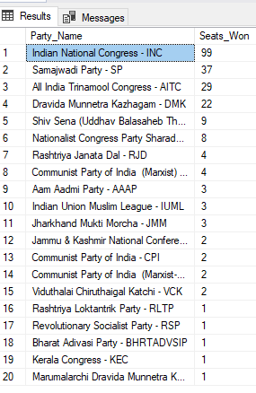

**7) Add new column field in table partywise_results to get the Party Allianz as NDA, I.N.D.I.A and OTHER**

ALTER TABLE partywise_results

ADD party_alliance VARCHAR(50);

**I.N.D.I.A Allianz**

UPDATE partywise_results

SET party_alliance = 'I.N.D.I.A'

WHERE party IN (

    'Indian National Congress - INC',

    'Aam Aadmi Party - AAAP',

    'All India Trinamool Congress - AITC',

    'Bharat Adivasi Party - BHRTADVSIP',

    'Communist Party of India  (Marxist) - CPI(M)',

    'Communist Party of India  (Marxist-Leninist)  (Liberation) - CPI(ML)(L)',

    'Communist Party of India - CPI',

    'Dravida Munnetra Kazhagam - DMK',

    'Indian Union Muslim League - IUML',

    'Jammu & Kashmir National Conference - JKN',

    'Jharkhand Mukti Morcha - JMM',

    'Kerala Congress - KEC',

    'Marumalarchi Dravida Munnetra Kazhagam - MDMK',

    'Nationalist Congress Party Sharadchandra Pawar - NCPSP',

    'Rashtriya Janata Dal - RJD',

    'Rashtriya Loktantrik Party - RLTP',

    'Revolutionary Socialist Party - RSP',

    'Samajwadi Party - SP',

    'Shiv Sena (Uddhav Balasaheb Thackrey) - SHSUBT',

    'Viduthalai Chiruthaigal Katchi - VCK'

);

**NDA Allianz**

UPDATE partywise_results

SET party_alliance = 'NDA'

WHERE party IN (

    'Bharatiya Janata Party - BJP',

    'Telugu Desam - TDP',

    'Janata Dal  (United) - JD(U)',

    'Shiv Sena - SHS',

    'AJSU Party - AJSUP',

    'Apna Dal (Soneylal) - ADAL',

    'Asom Gana Parishad - AGP',

    'Hindustani Awam Morcha (Secular) - HAMS',

    'Janasena Party - JnP',

    'Janata Dal  (Secular) - JD(S)',

    'Lok Janshakti Party(Ram Vilas) - LJPRV',

    'Nationalist Congress Party - NCP',

    'Rashtriya Lok Dal - RLD',

    'Sikkim Krantikari Morcha - SKM'

);

**OTHER**

UPDATE partywise_results

SET party_alliance = 'OTHER'

WHERE party_alliance IS NULL;

**8) Which party alliance (NDA, I.N.D.I.A, or OTHER) won the most seats across all states?**

SELECT

party_alliance,

sum(Won) AS Seats_Won

FROM

partywise_results

GROUP BY

party_alliance

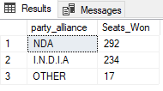

9) **Winning candidate's name, their party name, total votes, and the margin of victory for a specific state and constituency?**

select

cr.winning_candidate,

pr.party,

cr.total_votes,

cr.margin,

s.state,

cr.constituency_name

from

constituencywise_results cr

inner join partywise_results pr on cr.Party_ID=pr.Party_ID

inner join statewise_results sr on cr.Parliament_Constituency = sr.Parliament_Constituency

inner join states s on sr.State_ID = s.State_ID

WHERE s.State = 'Uttar Pradesh' AND cr.Constituency_Name = 'AMETHI';

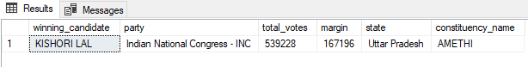

10) **What is the distribution of EVM votes versus postal votes for candidates in a specific constituency?**

SELECT

cd.EVM_Votes,

cd.postal_votes,

cd.total_votes,

cd.candidate,

cr.Constituency_name

from constituencywise_results cr join constituencywise_details cd

on cr.Constituency_ID = cd. Constituency_ID

where cr.Constituency_Name='AMETHI’

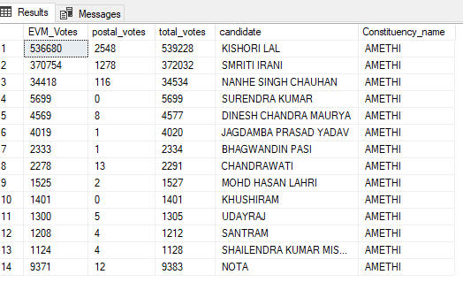

11) **Which parties won the most seats in s State, and how many seats did each party win?**

SELECT

    p.Party,

    COUNT(cr.Constituency_ID) AS Seats_Won

FROM

    constituencywise_results cr

JOIN

    partywise_results p ON cr.Party_ID = p.Party_ID

JOIN

    statewise_results sr ON cr.Parliament_Constituency = sr.Parliament_Constituency

JOIN states s ON sr.State_ID = s.State_ID

WHERE

    s.state = 'Andhra Pradesh'

GROUP BY

    p.Party

ORDER BY

    Seats_Won DESC;

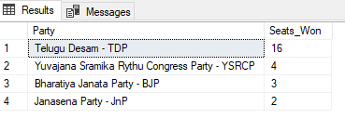

12) **What is the total number of seats won by each party alliance (NDA, I.N.D.I.A, and OTHER) in each state for the India Elections 2024**

SELECT

    s.State AS State_Name,

    SUM(CASE WHEN p.party_alliance = 'NDA' THEN 1 ELSE 0 END) AS NDA_Seats_Won,

    SUM(CASE WHEN p.party_alliance = 'I.N.D.I.A' THEN 1 ELSE 0 END) AS INDIA_Seats_Won,

SUM(CASE WHEN p.party_alliance = 'OTHER' THEN 1 ELSE 0 END) AS OTHER_Seats_Won

FROM

    constituencywise_results cr

JOIN

    partywise_results p ON cr.Party_ID = p.Party_ID

JOIN

    statewise_results sr ON cr.Parliament_Constituency = sr.Parliament_Constituency

JOIN

    states s ON sr.State_ID = s.State_ID

WHERE

    p.party_alliance IN ('NDA', 'I.N.D.I.A',  'OTHER')  -- Filter for NDA and INDIA alliances

GROUP BY

    s.State

ORDER BY

    s.State;

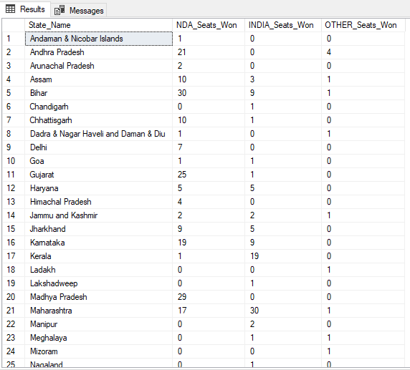

13) **Which candidate received the highest number of EVM votes in each constituency (Top 10)?**

SELECT TOP 10

    cr.Constituency_Name,

    cd.Constituency_ID,

    cd.Candidate,

    cd.EVM_Votes

FROM

    constituencywise_details cd

JOIN

    constituencywise_results cr ON cd.Constituency_ID = cr.Constituency_ID

WHERE

    cd.EVM_Votes = (

        SELECT MAX(cd1.EVM_Votes)

        FROM constituencywise_details cd1

        WHERE cd1.Constituency_ID = cd.Constituency_ID

    )

ORDER BY

    cd.EVM_Votes DESC;

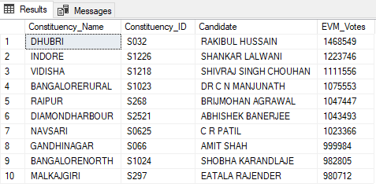

14) **Which candidate won and which candidate was the runner-up in each constituency of State for the 2024 elections?**

WITH RankedCandidates AS (

    SELECT

        cd.Constituency_ID,

        cd.Candidate,

        cd.Party,

        cd.EVM_Votes,

        cd.Postal_Votes,

        cd.EVM_Votes + cd.Postal_Votes AS Total_Votes,

        ROW_NUMBER() OVER (PARTITION BY cd.Constituency_ID ORDER BY cd.EVM_Votes + cd.Postal_Votes DESC) AS VoteRank

    FROM

        constituencywise_details cd

    JOIN

        constituencywise_results cr ON cd.Constituency_ID = cr.Constituency_ID

    JOIN

        statewise_results sr ON cr.Parliament_Constituency = sr.Parliament_Constituency

    JOIN

        states s ON sr.State_ID = s.State_ID

    WHERE

        s.State = 'Maharashtra'

)

SELECT

    cr.Constituency_Name,

    MAX(CASE WHEN rc.VoteRank = 1 THEN rc.Candidate END) AS Winning_Candidate,

    MAX(CASE WHEN rc.VoteRank = 2 THEN rc.Candidate END) AS Runnerup_Candidate

FROM

    RankedCandidates rc

JOIN

    constituencywise_results cr ON rc.Constituency_ID = cr.Constituency_ID

GROUP BY

    cr.Constituency_Name

ORDER BY

    cr.Constituency_Name;

15) **For the state of Maharashtra, what are the total number of seats, total number of candidates, total number of parties, total votes (including EVM and postal), and the breakdown of EVM and postal votes?**

SELECT

    COUNT(DISTINCT cr.Constituency_ID) AS Total_Seats,

    COUNT(DISTINCT cd.Candidate) AS Total_Candidates,

    COUNT(DISTINCT p.Party) AS Total_Parties,

    SUM(cd.EVM_Votes + cd.Postal_Votes) AS Total_Votes,

    SUM(cd.EVM_Votes) AS Total_EVM_Votes,

    SUM(cd.Postal_Votes) AS Total_Postal_Votes

FROM

    constituencywise_results cr

JOIN

    constituencywise_details cd ON cr.Constituency_ID = cd.Constituency_ID

JOIN

    statewise_results sr ON cr.Parliament_Constituency = sr.Parliament_Constituency

JOIN

    states s ON sr.State_ID = s.State_ID

JOIN

    partywise_results p ON cr.Party_ID = p.Party_ID

WHERE

    s.State = 'Maharashtra';

